Faculty Members:
Dr. Keyvan Pakshsir  Manager Director  Professor Of Medical Mycology  E.mail: pakshirk@sums.ac.ir  USID: https://usid.research.ac.ir/Center.php?id=44&collection=0 | 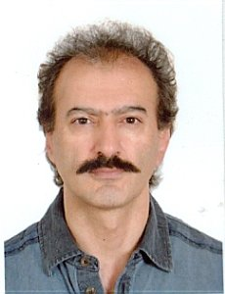

H. Index: 45

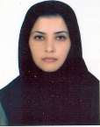 | Dr. Zahra Zareshahrabadi  Research Assistence  Assistant Professor of Medical Mycology  E.mail: zahrazarem368@gmail.com  USID: https://usid.research.ac.ir/Center.php?id=44&collection=0
 | H. index: 27

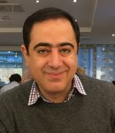 | Dr. Kamiar Zomorodian  Faculty Member  Professor Of Medical Mycology  E.mail: zomorodian@sums.ac.ir  USID: https://usid.research.ac.ir/Center.php?id=44&collection=0
 | H. index: 41

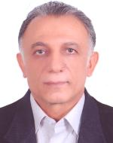 | Dr. Mohammad Hossein Motazedian  Faculty Member  Professor of Medical Parasitology  E.mail: motazedm@sums.ac.ir  USID: https://usid.research.ac.ir/Center.php?id=44&collection=0
 | H. Index: 35
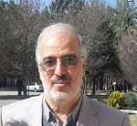 | Dr. Seyyed Mahmoud Sadjjadi  Faculty of Member  Professor of Medical parasitology  E.mail: smsadjjadi@sums.ac.ir  USID: https://usid.research.ac.ir/Center.php?id=44&collection=0
 | H. index: 31
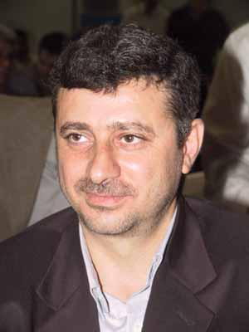 | Dr. GholamReza Hatam  Faculty Member  Professor of Medical Parasitolgy  E.mail: hatamghr@sums.ac.ir  USID: https://usid.research.ac.ir/Center.php?id=44&collection=0
 | H. Index: 35

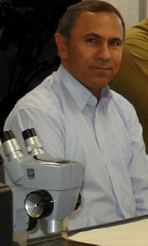 | Dr. Bahador Shahriari  Faculty Member  Professor Of Medical parasitology  E.mail: sarkarib@sums.ac.ir  USID: https://usid.research.ac.ir/Center.php?id=44&collection=0
 | H. index: 25

 | 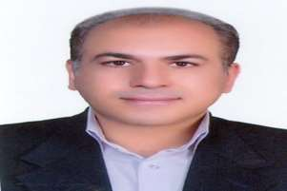 | Dr. Bahador Shahriari  Faculty Member  Assistant Professor Of Medical mycology  E.mail: h_khodadadi@sums.ac.ir  USID: https://usid.research.ac.ir/Center.php?id=44&collection=0
 |  | H. index: 16

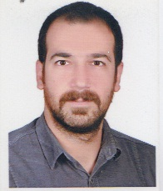 | Dr. Aref Teimouri  Faculty Member  Assistant Professor Of Medical parasitology  E.mail: aref_teimouri@sums.ac.ir  USID: https://usid.research.ac.ir/Center.php?id=44&collection=0
 | H. index: 19

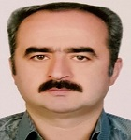 | Dr. Bahador Shahriari  Faculty Member  Professor Of Medical parasitology  E.mail: asgarig@sums.ac.ir  USID: https://usid.research.ac.ir/Center.php?id=44&collection=0
 | H. index: 24

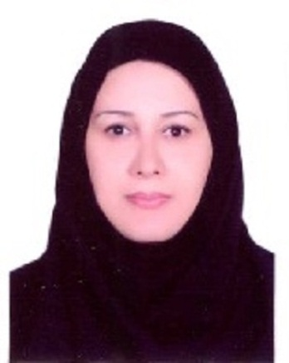 | Dr. Bahador Shahriari  Faculty Member  Assistant Professor Of Medical parasitology  E.mail: mikaeelf@sums.ac.ir  USID: https://usid.research.ac.ir/Center.php?id=44&collection=0
 | H. index: 14

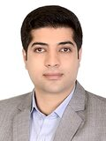 | Dr. Mohammad Saleh Bahreini  Faculty Member  Assistant Professor Of Medical parasitology  E.mail: bahreinim@sums.ac.ir  USID: https://usid.research.ac.ir/Center.php?id=44&collection=0
 | H. index: 9

